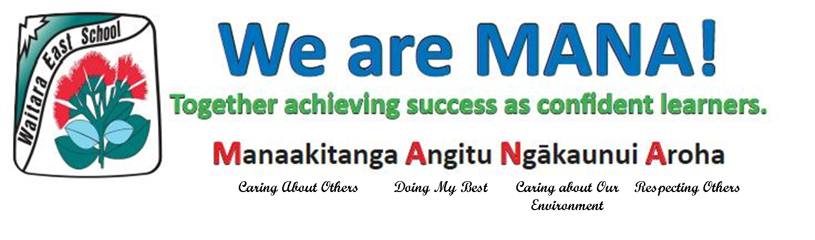**Week 2 Term 3 Newsletter** 4 August, 2017.

***Principal's Message***

Kia Ora Whanau,

It has been great to get out and witness some learning happening in classes this week. I am proud to see our children settling into the term and re-establishing their routines of learning.

Our **MANA** focus for the week at school has been using our manners. Today in assembly one student was identified in each class and given a **Book Award**:- **Kainana Anterea, Maia Vete Reade, Chazz Harris, Emma Schwass, Rakaii Black, Ataliyah Wallace-Soal, Kymani Makatea Cooper** and **Raequarn Rangitonga Brewer.**

Congratulations also to **Carter Stechman, Jaius Gilligan** and **Tayaitupua Makatea** **Cooper** who received **Principal Awards**.

**Perrie Topia.**

**Rugby Report**

On Friday 28th, 2017 the Waitara East Rugby team played St Joseph's New Plymouth. The first half was a strong display of running rugby with our boys going into halftime ahead 27 to 28 points. The second half score changed many times with St Joseph's edging ahead to win 46 to 48. We are very proud of the boys effort and sportsmanship during the match. A special thanks to Matua Mike for his time and effort preparing the boys for their matches this season.

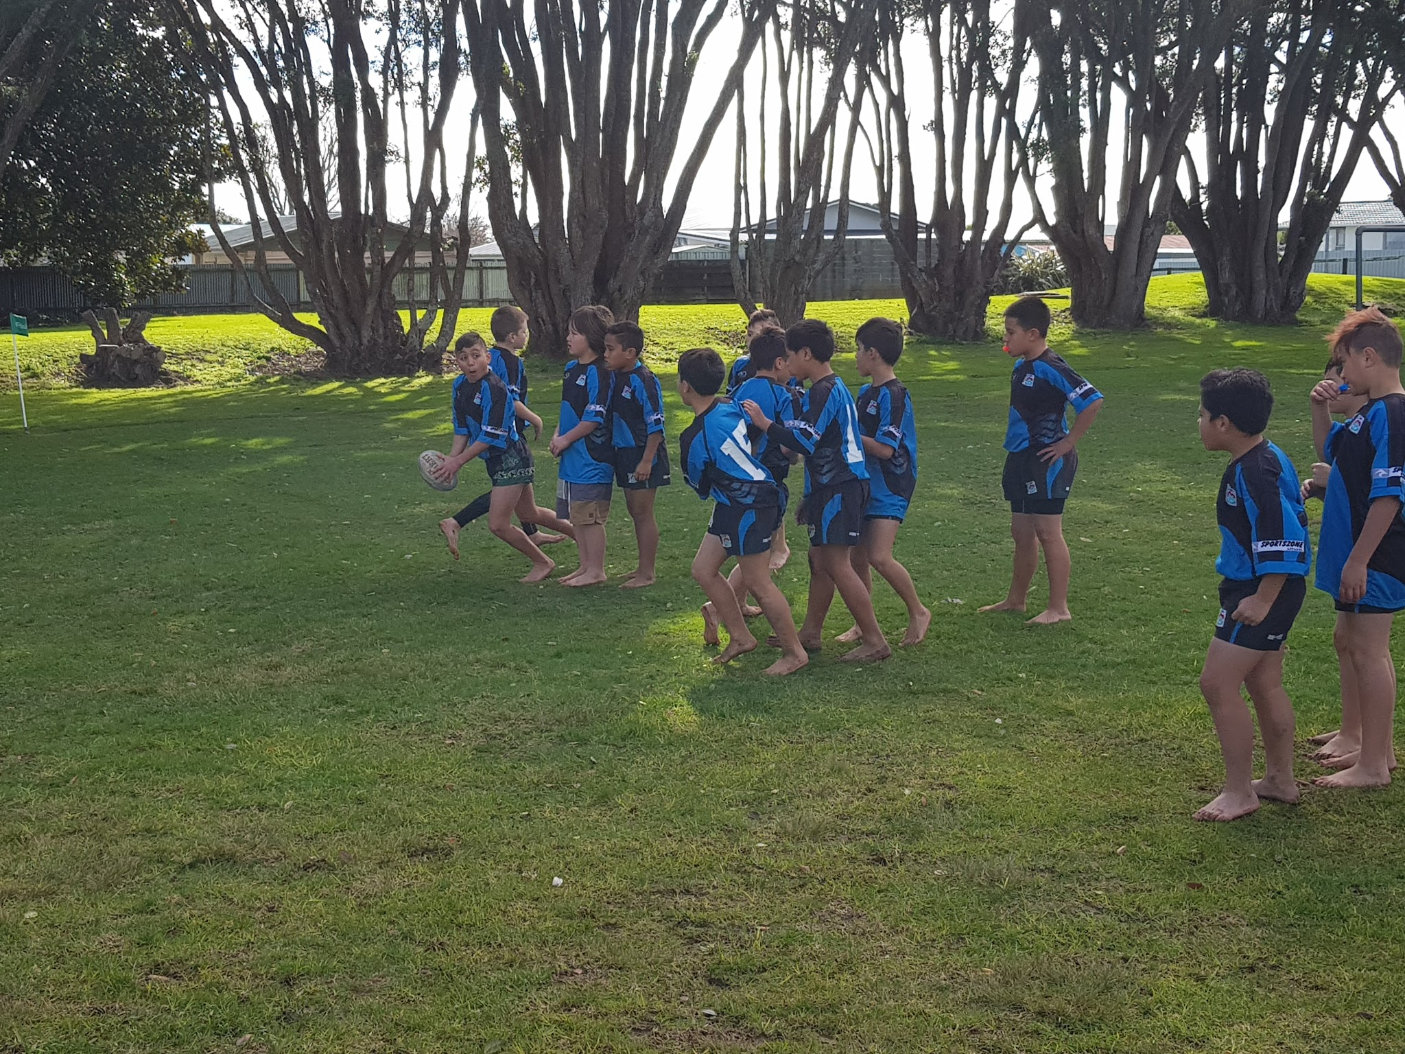 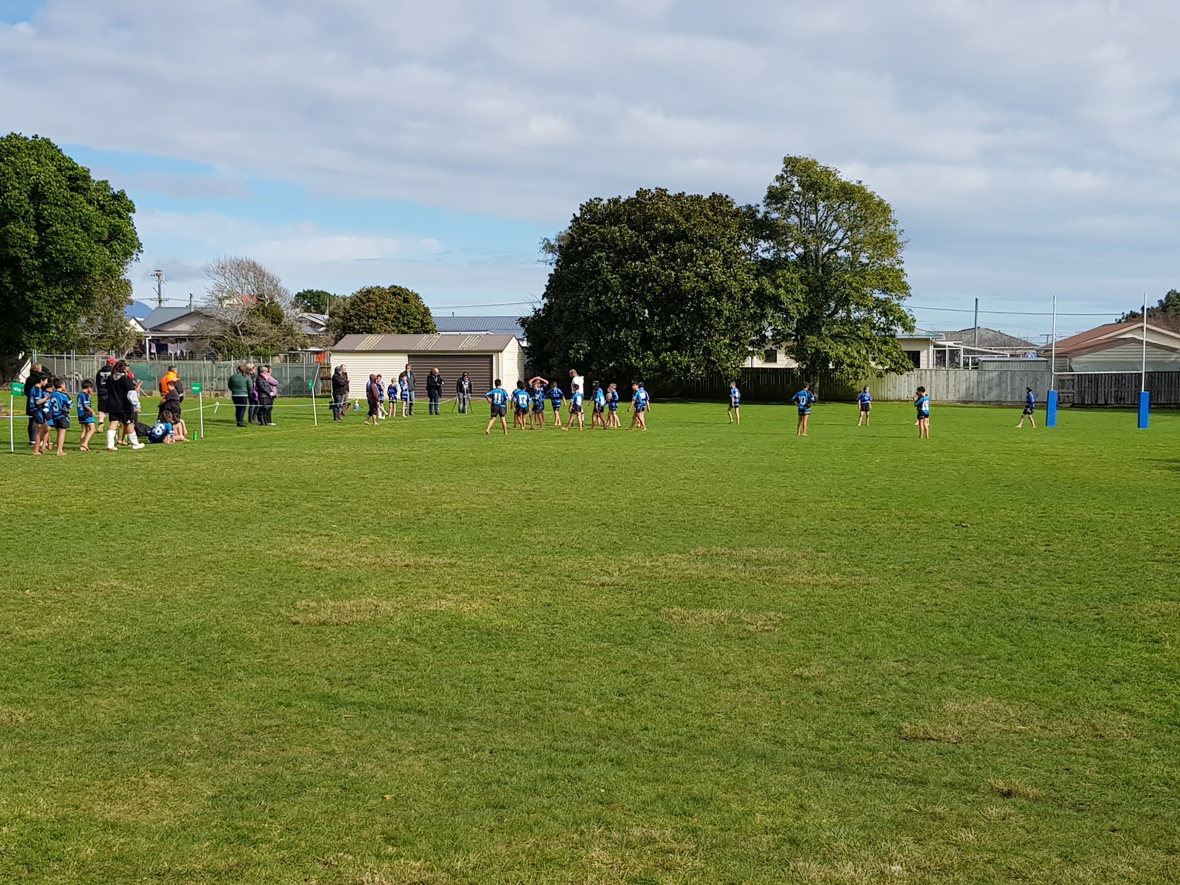

**Netball Report**

Last week our girls also played St Joseph's from New Plymouth in a Netball Semifinal. The girls played very well and the score was very close throughout the game. The final result did not favour Waitara East with our girls going down 13-6. A big thanks to Kym Reade for coaching our Netball girls this year. Thank you also to Daisy Pennington and Rebecca Reade for coaching our Year 1 and 2’s and Theresa Vete for coaching our Year 3 and 4’s.

**Scabies notice**

**Student Contribution** Chapter Chat.

Room 1 and 9 are participating in chapter chat this term. Chapter chat is based around a chapter book which is read aloud in class or through an audio file.

The chapter book chat is on every Friday at 10-10.55am. The chat is based around 10 questions which are created from the story. Also each week tasks are posted for the kids to complete and they share them during the chat on twitter.

The weekly tasks and questions are posted every Friday night on the Facebook Page.

You can check the Chapter Chat Facebook page to see which tasks have been chosen as examples of awesome work!.

Last Friday Dallas had his work chosen like many other children from our kura, here is Dallas’ flag based on the current chapter chat book Ghost by author Jason Reynolds.

.By **Ashton and Dallas – Room 1**

**Rugby breakdown**

A great season by  our Waitara East Rugby Team winning 4 out of 4 in the round robin, having scored 212 points going into a semi-final which was a dramatic high paced full of action game unfortunately going down 48-46.

All of the players showed great Mana throughout the campaign on and off the field.

Thank you to all of the parents and helpers for supporting our team.

Special thanks to Gavin, J.T, Kahn and Ashton.

**Captain Dallas**

Our Public Health Nurse has asked that we inform you that there is a scabies outbreak at the moment. Early signs are itchy rash in places such as forearm, around the waist, between fingers, buttocks and under armpits. This is spread by direct contact with the infected person and sharing sheets and clothes. Treatment can be obtained from the Chemist, Doctor and please ring Naomi our Public Health Nurse on 027 2816463.

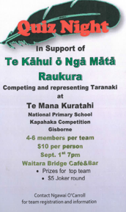

WHakATAUKI

***Ko te manu e kai ana i te miro noona te ngahere***

*The bird that eats the miro reigns in the forest*

***Ko te manu e kai ana i te matauranga noona te ao.***

*The bird that feeds on knowledge has access to the world.*

